Sprint 1:

Task 1 ERD diagram
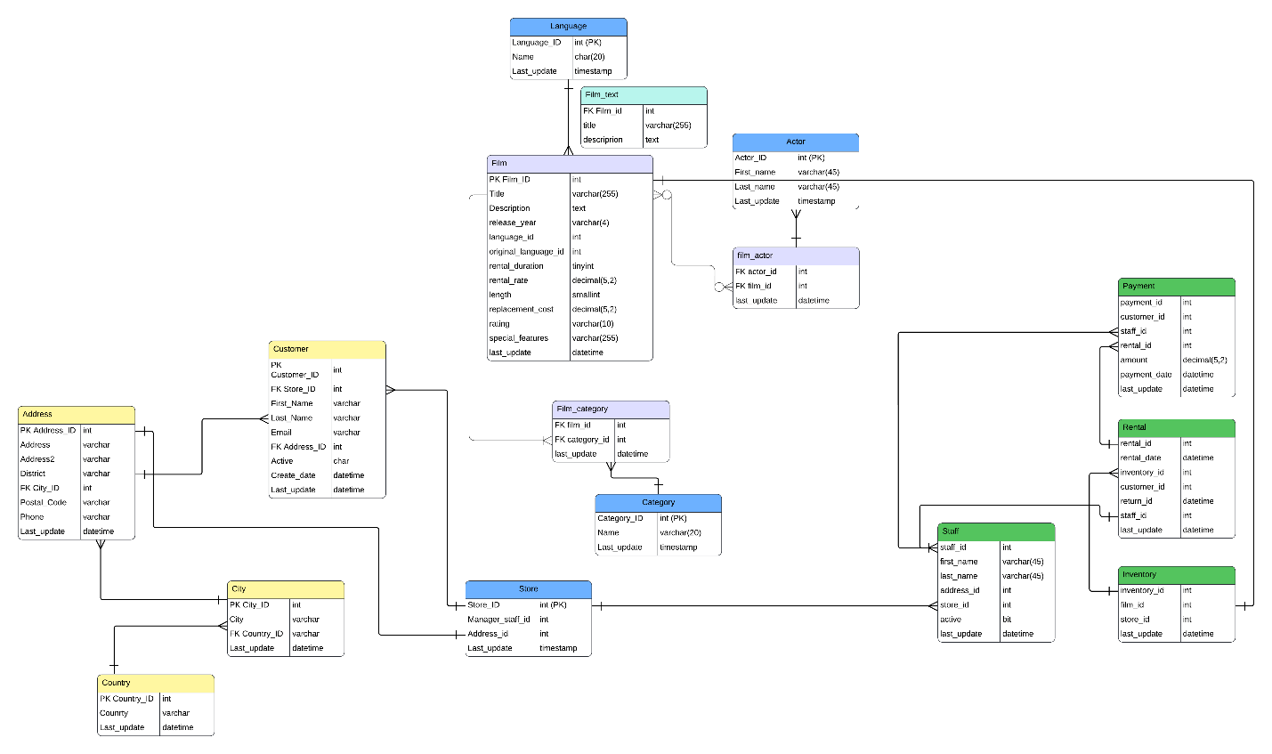
544_ERD_week3(1): Lucidchart

Task 2 Data dictionaries
Customer
Customer_ID | int | Primary Key of a table
Store_ID | int | Customer Store (Ref: Store)
First_Name | Varchar(45) | Customer first name
Last_Name | Varchar(45) | Customer last name
Email | Varchar(50) | Customer email
Address_ID | int | Customer Address (Ref: Address)
Active | Char(1) | 1= active/ 0=inactive
Create_Date | datetime | Created date
Last_Update | datetime | Date of last record update

Address
Address_ID | int | Primary Key of a table
Address | Varchar(50) | Address
Address2 | Varchar(50) | Address 2 (Apt/ building #)
District | Varchar(20) | District
City_ID | int | City (Ref: City)
Postal_Code | Varchar(10) | Postal Code
Phone | Varchar(20) | Phone
Last_Update | datetime | Date of last record update

City
City_ID | int | Primary key of a table
City | Varchar(50) | City name
Country_ID | int | Country id (Ref: Country)
Last_Update | datetime | Date of last record update

Country
Country_ID | int | Primary key of a table
Country | Varchar(50) | Country name
Last_Update | datetime | Date of last record update

Payment
payment_id | int | id of all the payment
customer_id | int | id of 7 customers
staff_id | int | id of 2 staff members
rental_id | int | id of the rental
amount | decimal (5, 2) | amount of the payment
payment_date | datetime | the date of the payment
last_update | datetime | last date of the update

Rental
rental_id | int | id of the rental
rental_date | datetime | date that the movie was rent
inventory_id | int | the id of the inventory
customer_id | int | id of 7 customers
return_id | datetime | date that the movie was return
staff_id | int | id of 2 staff members
last_update | datetime | last date of the update

Staff
staff_id | int | id of 2 staff members
first_name | varchar (45) | the first name of the staff
last_name | varchar (45) | the last name of the staff
address_id | int | the address id
store_id | int | the id of the store
active | bit | the 1 means that is active and 0 that is not active
last_update | datetime | last date of the update

Inventory
inventory_id | int | the id of the inventory
film_id | int | the id of the film
store_id | int | the id of the store
last_update | datetime | last date of the update

Store:
store_id | int | Unique identifier for each store
manager_staff_id | int | ID of the staff member who manages the store (FK to Staff)
address_id | int | Store address ID (FK to Address)
last_update | timestamp | Date and time of last record update

Actors:
actor_id | int | Unique identifier for each actor
firstname | Varchar(45) | Actor first name
lastname | Varchar(45) | Actor last name
last_update | timestamp | Date and time of last record update

Language:
language_id | int | Unique identifier for each language
name | char(20) | Language name
last_update | timestamp | Date and time of last record update

Category
category_id | tinyint | Unique identifier for each category
name | varchar(25) | Category name
last_update | timestamp | Date and time of last record update

Film
Film_ID | int | Unique film identifier
Title | varchar(255) | Film title
Description | text | Description summary
release_year | varchar(4) | Film release year
language_id | Int | Language of the film
original_language_id | int | Original language of the film
rental_duration | tinyint | Film rental duration in days
rental_rate | decimal(5,2) | Price to rent the film
length | smallint | Film length in minutes
replacement_cost | decimal(5,2) | Cost to replace the lost film
rating | varchar(10) | Film rating (PG, etc.)
special_features | varchar(255) | If extra features are present
last_update | datetime | Date of last record update

Film_Category
film_id | int | Film id from Film table
category_id | int | Film category from category table
last_update | datetime | Date of last record update

Category
Category_ID | int | Unique category identifier
Name | varchar(20) | Film category name
Last_update | timestamp | Date of last record update

Film_text
Film_id | int | Film ID from Film table
title | varchar(255) | Film title for text search
description | text | Film description for full-text indexing

Task 3 Written team "contract"/plan

1. Team Members and Roles
Name | Skills | Assigned Role
Abdalla Alamen | Visualizations and python coding | Leads project planning, team and task coordination, and develop ETL pipelines.
Carlos Calzada | Python coding, ETls, SQL and team leading | Designs databases and develops ETL pipelines for data integration, and visual dashboards.
Mariia Karvonen | Merging, documentation and validation | Create SQL queries and prepare documentation and design reports.
Rena Sanda | SQL, queries, views and stored procedures | Writes and optimizes SQL and MongoDB queries for data analysis, and indexes for optimization.

2. Project Management Platform and Strategy
Primary Platform: Trello, Microsoft Teams and Word.
Communication Tools: Teams
File Management: Shared Word
Strategy: Working in short sprints to deliver incremental progress and followup accordingly.
Tasks will be tracked in Trello, with labels for To Do, In Progress, Review, and Done.
Each member will update task status before weekly meetings.
Deadlines and deliverables will be reviewed during sprint planning and retrospectives.

3. Scheduling and Meeting Plan
Stand-ups: Twice per week
Purpose: Quick progress updates — What I did, What I’ll do next, Any blockers.
Meeting Platform: Microsoft Teams and in-person

Task 4 Query List 1 queries

Business Scale Analysis: Count Total Customers
SELECT
COUNT(*) AS total_customers
FROM
customer;

Total_customers | 599

Business Scale Analysis: Count Total Films
SELECT
COUNT(*) AS total_films
FROM
film;

Total films | 1000

Stakeholder Identification: Identify Actors with Most Film Appearances
SELECT
A.actor_id,
A.first_name,
A.last_name,
COUNT(FA.film_id) AS film_count
FROM
film_actor AS FA
JOIN
actor AS A ON FA.actor_id = A.actor_id
GROUP BY
A.actor_id,
A.first_name,
A.last_name
ORDER BY
film_count DESC;

Actor ID | Name | Film count | Last update
107 | Gina DEGENERES | 42 | 2006-02-15
102 | WALTER TORN | 41
198 |  | 40
181 |  | 39
23 |  | 37
81 |  | 36
60 |  | 35
144 |  | 35
13 |  | 35
37 |  | 35
158 |  | 35
106 |  | 35
108 |  | 34
65 |  | 34
105 |  | 34
150 |  | 34
92 |  | 34
27 |  | 33
127 |  | 33
187 |  | 33

Geographic Footprint: Count Customers per Country
SELECT
co.Country,
COUNT(cust.customer_id) AS customer_count
FROM
customer AS cust
JOIN
address AS a ON cust.address_id = a.address_id
JOIN
city AS ci ON a.city_id = ci.city_id
JOIN
country AS co ON ci.country_id = co.country_id
GROUP BY
co.Country
ORDER BY
customer_count DESC;

India | 60
China | 53
US | 36
Japan | 31
Mexico | 30
Brazil | 28
Russian | 28
Philippines | 20
Turkey | 15
Indonesia | 14
Nigeria | 13
Argentina | 13
South Africa | 13
Taiwan | 10
UK | 9
Iran | 8
Poland | 8
Italy | 7
Venezuela | 7
Germany | 7

Geographic Footprint: store address
SELECT
s.store_id,
a.address,
a.district,
ci.city,
co.country
FROM
store AS s
JOIN
address AS a ON s.address_id = a.address_id
JOIN
city AS ci ON a.city_id = ci.city_id
JOIN
country AS co ON ci.country_id = co.country_id;

Id | address | district | city | country
1 | 47 MySakila Drive |  | Lethbridge | Canada
2 | 28 MySQL Boulevard |  | Woodridge | Australia

Calculate Total Sales per Store
SELECT
S.store_id,
SUM(P.amount) AS total_sales
FROM
payment AS P
JOIN
rental AS R ON P.rental_id = R.rental_id
JOIN
inventory AS I ON R.inventory_id = I.inventory_id
JOIN
store AS S ON I.store_id = S.store_id
GROUP BY
S.store_id
ORDER BY
total_sales DESC;

Store id | Total sales
1 | 33679.79
2 | 33726.770000000004

Timeline: Find Earliest and Latest Rental Dates
SELECT
MIN(rental_date) AS earliest_rental,
MAX(rental_date) AS latest_rental
FROM
rental;

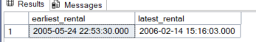

Timeline: Count Rentals per Month
SELECT
YEAR(rental_date) AS year,
MONTH(rental_date) AS month,
COUNT(*) AS rental_count
FROM
rental
GROUP BY
YEAR(rental_date),
MONTH(rental_date)
ORDER BY
year ASC,
month ASC;

Year | Month | Rental Count
2005 | 5 | 1156
2005 | 6 | 2311
2005 | 7 | 6709
2005 | 8 | 5686
2006 | 2 | 182

Value Analysis: Calculate Total Revenue
SELECT
SUM(amount) AS total_revenue
FROM
payment;

total_revenue | 67416.51

Value Analysis: Calculate Total Revenue per Film Category
SELECT
C.name AS category_name,
SUM(P.amount) AS total_revenue
FROM
film AS F
JOIN
film_category AS FC ON F.film_id = FC.film_id
JOIN
category AS C ON FC.category_id = C.category_id
JOIN
inventory AS I ON F.film_id = I.film_id
JOIN
rental AS R ON I.inventory_id = R.inventory_id
JOIN
payment AS P ON R.rental_id = P.rental_id
GROUP BY
C.name
ORDER BY
total_revenue DESC;

sports | 5314.21
SF | 4756.9800000000005
anime | 4656.3
drama | 4587.39
comedy | 4383.58
action | 4375.85
New | 4351.62
Game | 4281.33
foreign | 4270.67
family | 4226.070000000001
documentary | 4217.52
horror | 3722.54
children | 3655.55
classics | 3639.59
travel | 3549.6400000000003
music | 3417.7200000000003

Actor Film Category Count
SELECT
A.first_name,
A.last_name,
C.name AS category_name,
COUNT(F.film_id) AS film_count
FROM
actor AS A
JOIN
film_actor AS FA ON A.actor_id = FA.actor_id
JOIN
film AS F ON FA.film_id = F.film_id
JOIN
film_category AS FC ON F.film_id = FC.film_id
JOIN
category AS C ON FC.category_id = C.category_id
GROUP BY
A.first_name,
A.last_name,
C.name
ORDER BY
A.first_name ASC,
A.last_name ASC,
film_count DESC;

